Capstone Project
Machine Learning Engineer Nanodegree
Nicolás Alvarez
August 22nd, 2016

I. Definition

Project Overview
According to the CDC motor vehicle safety division, one in five car accidents is caused by a distracted driver. Sadly, this translates to 425,000 people injured and 3,000 people killed by distracted driving every year in USA.
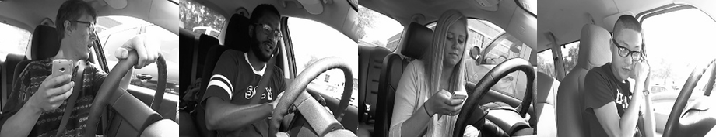
This project is based on a Kaggle competition called “State Farm Distracted Driver Detection”. Given a dataset of 2D dashboard camera images, I developed a ConvNet that is capable to classify each driver's behavior, that is, if they are driving attentively or if they are distracted, for example, taking a selfie with their friends in the backseat.

Problem Statement
The project's goal is to predict the likelihood of what the driver is doing in each picture. The main tasks involved are the following:
- Download and preprocess the train, validation and test datasets.
- Build and train the ConvNet classifier that can determine what the driver is doing in each picture.
- Measure performance on validation set and fine tune the model if necessary.
- Predict images in the test dataset and submit the predictions file to the Kaggle competition.

Metrics
Two metrics are used to measure the performance of the ConvNet classifier: Precision and Multi-class logarithmic loss.
The first one is given by:

where tp is the true positives and fp the false positives.

The multi-class logarithmic loss, the one used in Kaggle's competitions, is given by:

where N is the number of images in the test/validation set, M is the number of image class labels, log is the natural logarithm, y_ij is 1 if observation i belongs to class j and 0 otherwise, and p_ij is the predicted probability that observation i belongs to class j.

II. Analysis

Data Exploration
The data provided by the competition consists of the following files:
- imgs.zip: zipped folder of all (train/test) images
- sample_submission.csv: sample submission file in the correct format
- driver_imgs_list.csv: list of training images, their subject (driver) id, and class id
The examples are driver images of 640px x 480px, each taken in a car with a driver doing something in the car (texting, eating, talking on the phone, makeup, reaching behind, etc).
The 10 classes to predict are:
- c0: safe driving
- c1: texting – right
- c2: talking on the phone – right
- c3: texting – left
- c4: talking on the phone – left
- c5: operating the radio
- c6: drinking
- c7: reaching behind
- c8: hair and makeup
- c9: talking to passenger
The train and test data are split on the drivers, such that one driver can only appear on either train or test set.
The train dataset has 22423 labeled images and the test dataset has 79726 unlabeled examples. The train data was split in two subsets, one of 17937 examples for training and another one of 4485 examples for validation.

Exploratory Visualization
The Figure 1 shows a bar diagram of the number of occurrences of each class. From a total of 22424 example in the training set, each class has between 2000 and 2500 examples. Despite it is a small dataset, it is balanced between classes.
On the other hand, in Figure 2 is shown the examples distribution in function of the drivers. Images of the dataset come from just 26 drivers, having approximately 80 images per every class per every driver. This is a very important thing to be considerer when splitting the dataset in training and validation sets for avoiding overfitting.
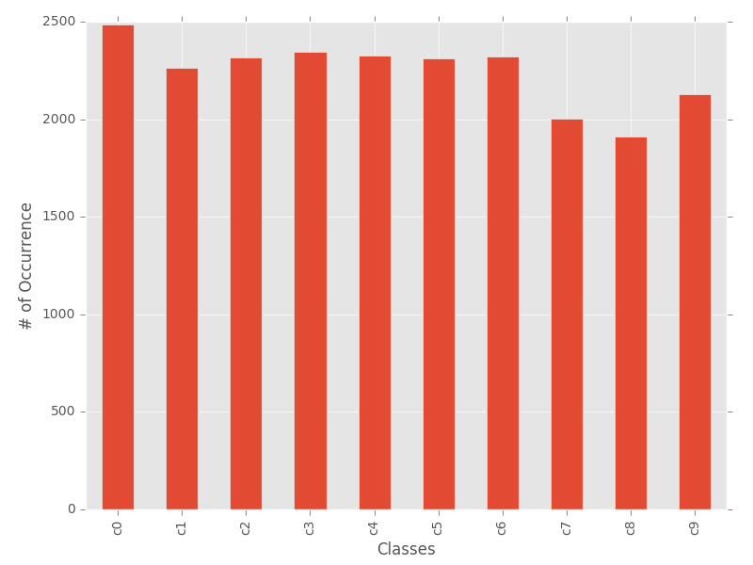Figure 1: Occurrences per Class

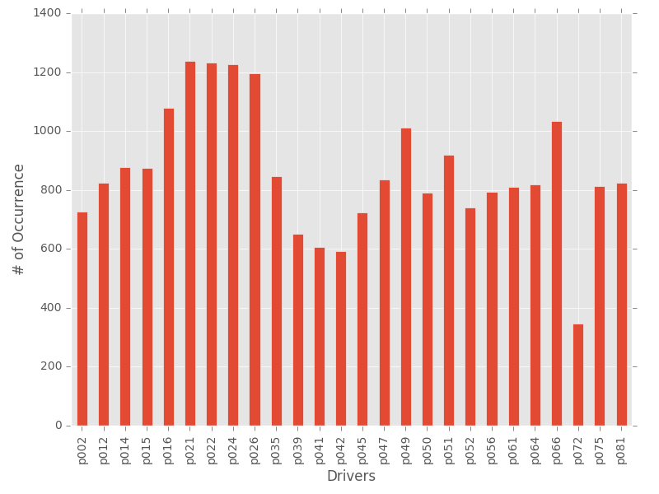Figure 2: Occurrences per Driver

Algorithms and Techniques
Nowadays, Convolutional Networks, also known as ConvNets, or some close variant are used in most neural networks for image recognition. Making the explicit assumption that the inputs are images, these networks use a special architecture which is particularly well-adapted to classify images. This architecture vastly reduces the amount of parameters in the network, making ConvNets fast to train. Also ConvNets outputs an assigned probability for each class, as it is required by the competition rules.
The layers of a ConvNet have neurons arranged in 3 dimensions: width, height, depth. As shown in Figure 3, the neurons in a layer are only connected to a small region of the layer before it, instead of all of the neurons in a fully-connected manner.

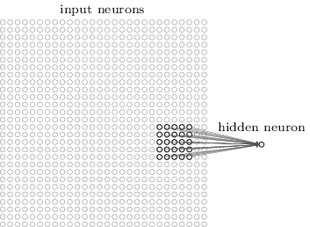Figure 3: Hidden neuron in a ConvNet
Generally speacking, a ConvNet is a sequence of layers (Convolutional Layer, Pooling Layer and Fully-Connected Layer), and every layer of a ConvNet transforms one volume of activations to another through a differentiable function. In this way, ConvNets transform the original image layer by layer from the original pixel values to the final class scores.
The following parameters can be tuned to optimize the ConvNet to be implemented:
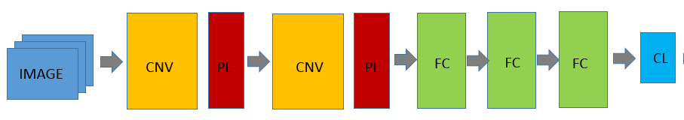Figure 4: ConvNet Architecture Example
- Training parameters
  - Number of epochs
  - Batch size
  - Optimization algorithms for learning, such as Gradient Descent or Adagrad
  - Learning rate (initial value and rate decay)
  - Dropout probability (for avoiding overfitting)
- Neural network architecture
  - Number of layers
  - Layer types (convolutional, fully-connected, or pooling)
  - Layer parameters (no. of neurons, bias and weight initialization)
- Preprocessing parameters (see the Data Preprocessing section)

Benchmark

The Private Leaderboard of the State Farm Distracted Driver Detection Competition, which is computed on 75% of the test set, will be used as benchmark for this project. The goal is to arrive to a solution that is in the top NNN of the competition.

III. Methodology
_(approx. 3-5 pages)_

Data Preprocessing
The training dataset is not large enough for training the model, so some distortions are apply to the images. The following preprocessing is apply to the training datasets' images:
- Check that all images have size 640px by 480px-
- Resize the original images from 640px by 480px to 64px by 48px.
- Save images in binary files, in batches up to 30MB per file, formatted as follows:
  - <1 x label><height*width*depth x pixel>
- Convert images to a squared form adding zero pixels as padding to a size of 1.2 the width of the image.
- Randomly crop the image to a size of 64px by 48px.
- In a random order, apply the following distortions:
  - Randomly adjust the brightness.
  - Randomly adjust the contrast.
  - Randomly adjust the saturation.
  - Randomly adjust the hue.
- Finally, linearly scales the image to have zero mean and unit norm.

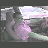

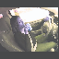Figure 5: Processed images examples

Implementation
In this section, the process for which metrics, algorithms, and techniques that you implemented for the given data will need to be clearly documented. It should be abundantly clear how the implementation was carried out, and discussion should be made regarding any complications that occurred during this process. Questions to ask yourself when writing this section:
- _Is it made clear how the algorithms and techniques were implemented with the given datasets or input data?_
- _Were there any complications with the original metrics or techniques that required changing prior to acquiring a solution?_
- _Was there any part of the coding process (e.g., writing complicated functions) that should be documented?_

Refinement
In this section, you will need to discuss the process of improvement you made upon the algorithms and techniques you used in your implementation. For example, adjusting parameters for certain models to acquire improved solutions would fall under the refinement category. Your initial and final solutions should be reported, as well as any significant intermediate results as necessary. Questions to ask yourself when writing this section:
- _Has an initial solution been found and clearly reported?_
- _Is the process of improvement clearly documented, such as what techniques were used?_
- _Are intermediate and final solutions clearly reported as the process is improved?_

IV. Results
_(approx. 2-3 pages)_

Model Evaluation and Validation
In this section, the final model and any supporting qualities should be evaluated in detail. It should be clear how the final model was derived and why this model was chosen. In addition, some type of analysis should be used to validate the robustness of this model and its solution, such as manipulating the input data or environment to see how the model’s solution is affected (this is called sensitivity analysis). Questions to ask yourself when writing this section:
- _Is the final model reasonable and aligning with solution expectations? Are the final parameters of the model appropriate?_
- _Has the final model been tested with various inputs to evaluate whether the model generalizes well to unseen data?_
- _Is the model robust enough for the problem? Do small perturbations (changes) in training data or the input space greatly affect the results?_
- _Can results found from the model be trusted?_

Justification
In this section, your model’s final solution and its results should be compared to the benchmark you established earlier in the project using some type of statistical analysis. You should also justify whether these results and the solution are significant enough to have solved the problem posed in the project. Questions to ask yourself when writing this section:
- _Are the final results found stronger than the benchmark result reported earlier?_
- _Have you thoroughly analyzed and discussed the final solution?_
- _Is the final solution significant enough to have solved the problem?_

V. Conclusion
_(approx. 1-2 pages)_

Free-Form Visualization
In this section, you will need to provide some form of visualization that emphasizes an important quality about the project. It is much more free-form, but should reasonably support a significant result or characteristic about the problem that you want to discuss. Questions to ask yourself when writing this section:
- _Have you visualized a relevant or important quality about the problem, dataset, input data, or results?_
- _Is the visualization thoroughly analyzed and discussed?_
- _If a plot is provided, are the axes, title, and datum clearly defined?_

Reflection
In this section, you will summarize the entire end-to-end problem solution and discuss one or two particular aspects of the project you found interesting or difficult. You are expected to reflect on the project as a whole to show that you have a firm understanding of the entire process employed in your work. Questions to ask yourself when writing this section:
- _Have you thoroughly summarized the entire process you used for this project?_
- _Were there any interesting aspects of the project?_
- _Were there any difficult aspects of the project?_
- _Does the final model and solution fit your expectations for the problem, and should it be used in a general setting to solve these types of problems?_

Improvement
In this section, you will need to provide discussion as to how one aspect of the implementation you designed could be improved. As an example, consider ways your implementation can be made more general, and what would need to be modified. You do not need to make this improvement, but the potential solutions resulting from these changes are considered and compared/contrasted to your current solution. Questions to ask yourself when writing this section:
- _Are there further improvements that could be made on the algorithms or techniques you used in this project?_
- _Were there algorithms or techniques you researched that you did not know how to implement, but would consider using if you knew how?_
- _If you used your final solution as the new benchmark, do you think an even better solution exists?_

-----------

**Before submitting, ask yourself. . .**

- Does the project report you’ve written follow a well-organized structure similar to that of the project template?
- Is each section (particularly **Analysis** and **Methodology**) written in a clear, concise and specific fashion? Are there any ambiguous terms or phrases that need clarification?
- Would the intended audience of your project be able to understand your analysis, methods, and results?
- Have you properly proof-read your project report to assure there are minimal grammatical and spelling mistakes?
- Are all the resources used for this project correctly cited and referenced?
- Is the code that implements your solution easily readable and properly commented?
- Does the code execute without error and produce results similar to those reported?

If it's noted in your report that the training time is unrealistically long, such that it is not something that would be considered an "online" implementation, then we do not expect the reviewers to run your code in that regard. A good way to compromise on that, would be to try pickling4 your data after training, if possible. This would, in some sense, save the trained algorithm so that you could start the reviewer "after the training". I would personally suggest trying to avoid training times that approach more than a few minutes, if only because it then becomes a serious chore if something goes wrong and you have to re-train. The time required to do so seems unnecessary.

http://www.cdc.gov/motorvehiclesafety/distracted_driving/
https://www.kaggle.com
https://www.kaggle.com/c/state-farm-distracted-driver-detection
https://www.kaggle.com/c/state-farm-distracted-driver-detection/data
http://cs231n.github.io/convolutional-networks/
http://neuralnetworksanddeeplearning.com/chap6.html
https://www.kaggle.com/c/state-farm-distracted-driver-detection/leaderboard

